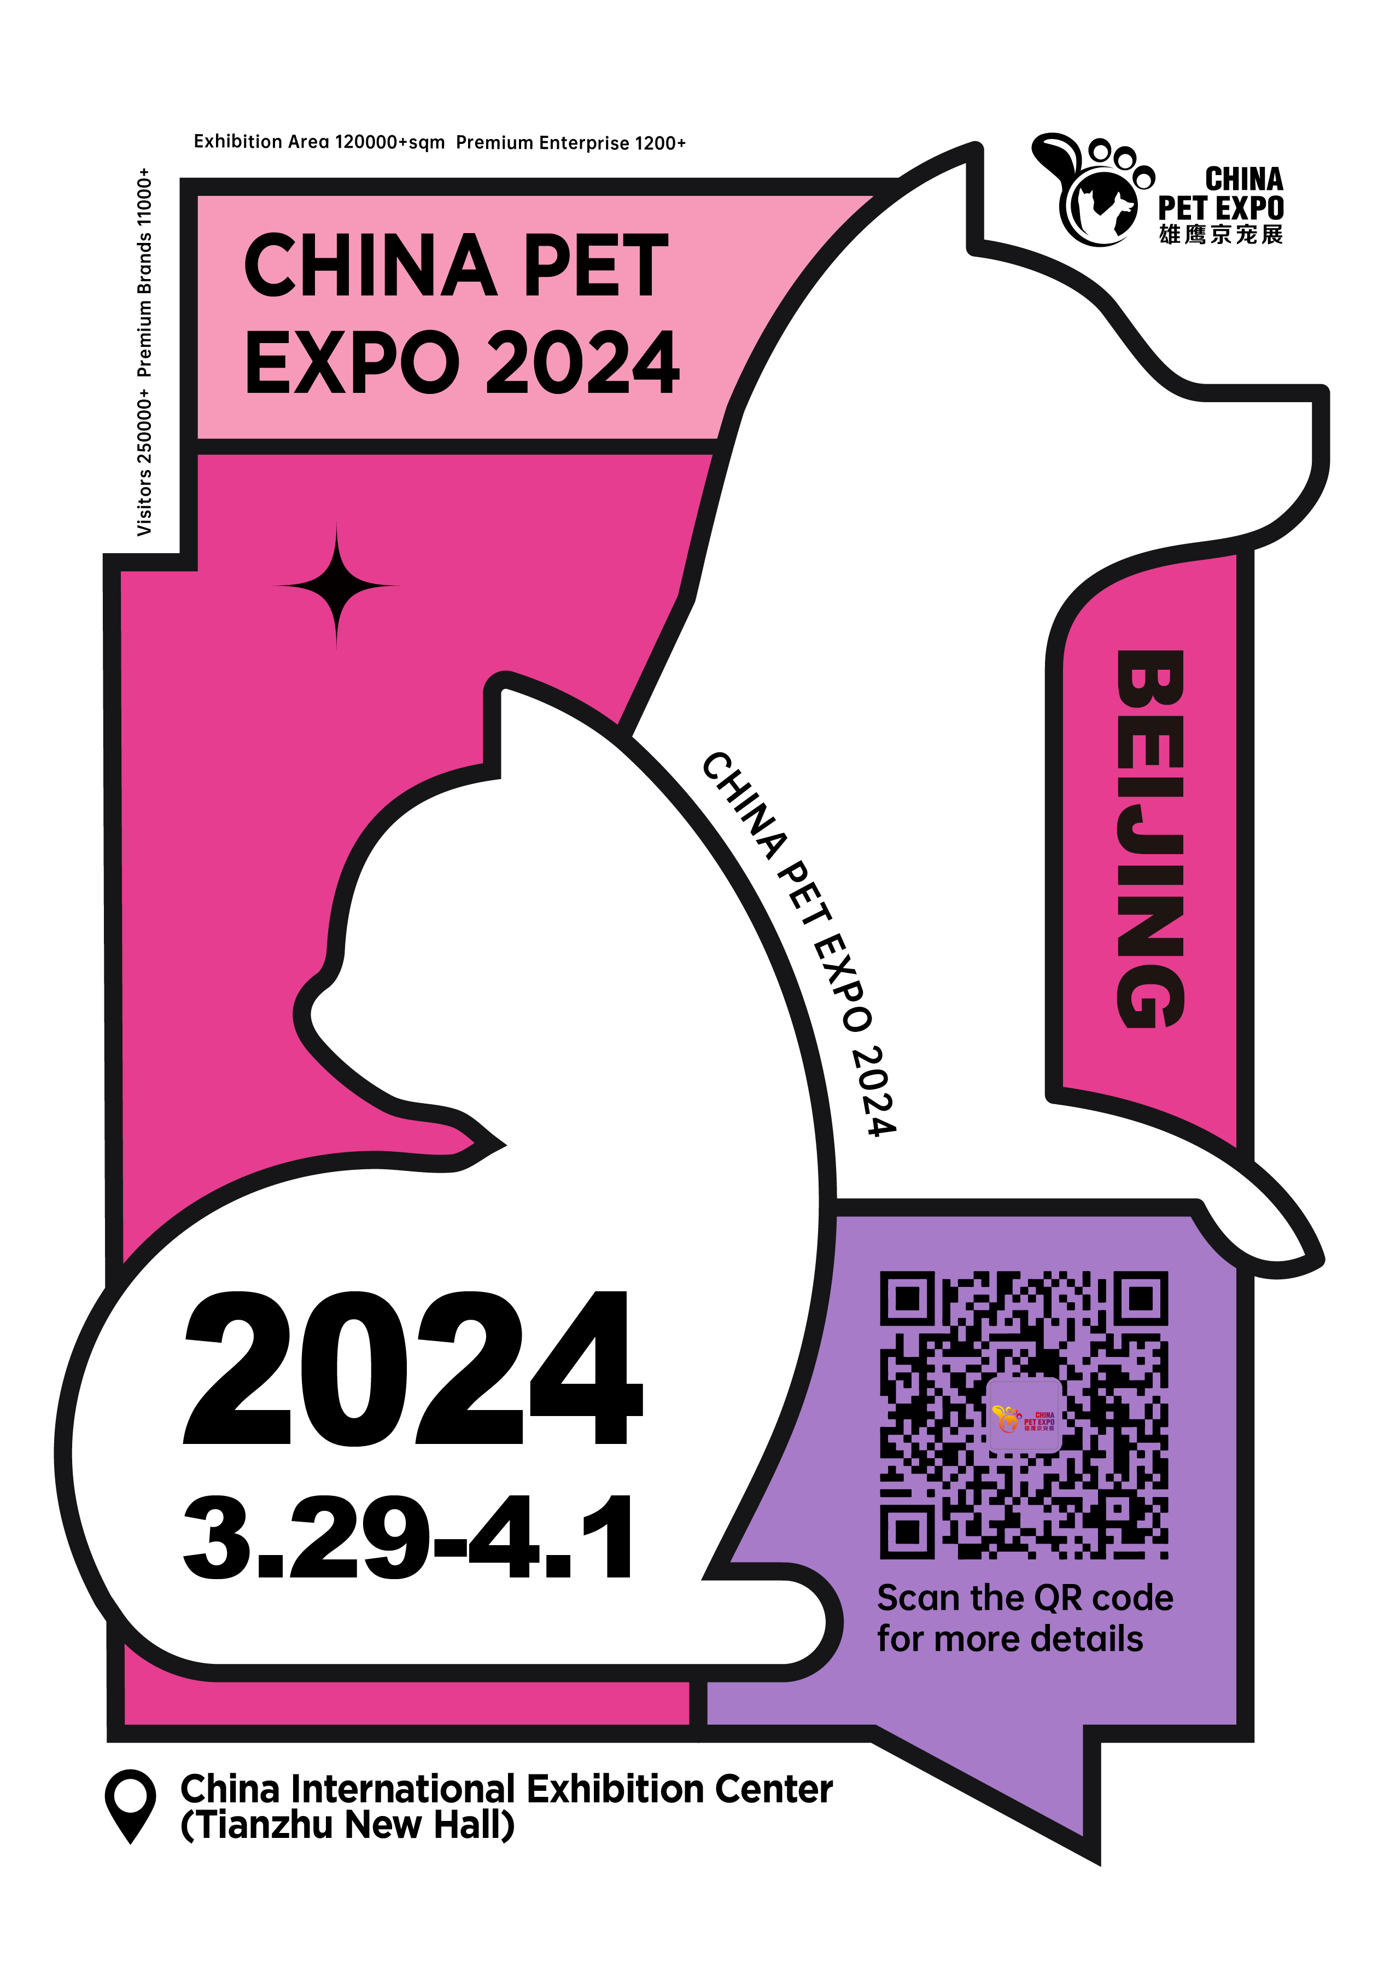
Profile of China Pet Expo 2024
China Beijing International Pet Supplies Exhibition (hereinafter referred to as China Pet Expo) has come across outstanding development in Nine years since the establishment in 2014. Being a large-scale industrial event with extremely great influence in pet industry in China. China Pet Expo will be organized in Beijing every spring. The 10th exhibition have been held successfully, which covered pet products and the latest technologies in this industry. It is a professional platform for pet brand promotion, market exploration, industrial trend guidance, business and trading, as well as gathering professionals in pet industry.
The 11th China Beijing International Pet Supplies Exhibition will launch in Beijing. China International Exhibition Center on March 29, 2024. Featuring an exhibition area of 120,000 square meters, the event brought together more than 1300 enterprises from domestic and abroad to join the exhibition. The show will bring together approximately 11,000 premium brands and 250,000 visitors from all over the world in four days. Nearly 30 relevant activities were organized at the same time, supplied an important platform for people who intend to promote the trading, launch products, find technical cooperation and communication. Moreover, it will bring a brand new experiences for all the pet lovers. We are looking forward your participation in 2024!
Conferences:
★ China Pet Industry Development Conference 2024
★China Pet Expo - Pet Product Incubator 2024
★ Cross - border Electricity Business Forum of China pet industry
★ The 10th China Pet Nutrition and Food Processing Technology Summit
★ The Pet Industry Distributors Union and Awarding ceremony

Registration and Preparation: March 27-28, 2024
Exhibition: March 29-April 1, 2024
Withdrawal: 16:00 April 1, 2024
China Pet Expo Exhibition Hall: China International Exhibition Center(Tianzhu New Hall)

China Pet Expo Exhibits
E1: Pet Food
E2: Pet Food
E3: Pet Food Suppliers,Small Animals
E4:Cat Products
W1: International Pet Product, International Pet Food
W2: Veterinary, Healthcare, Veterinary Equipment
W3: Pet Products
W4: Pet Products
Space pricing:
- Cost and arrangement: Standard booths and bare lands are provided for exhibitors.
Row Space(at least 36 m²) | Bare land: USD250/ m2 (at least 36 m2);
Standard Area(at least 9 m²) | Standard booth: USD2,500/9m2, 10% more for corner booths;
Note:
- Standard booth includes three panels, a lintel with company name, 1 front desk, 2 chairs, 2 spotlights, 1 socket (5A/220V) and 1 carpet.
B. Exhibitors need to arrange special decoration independently for bare land (please refer to the exhibitor handbook).
2. New product launch and technical seminar: ￥8000/time
Note: we will offer more sponsor solutions to cope with market strategy of enterprises. Please consult through calls.
Contact Us:
Add.: Room 1118 Block B, Xinlong Building, Xisanqi, Haidian District, Beijing Post Code: 100096
Contact person: Mrs Li
Tel.: 86-10-82967374 18211192036
Fax: 86-10-82967995
Email: 369373762@qq.com
Website: www.cpse-expo.com

